1)

class Animal {

void makeSound() {

print("Animal makes a sound.");

}

}

class Dog extends Animal {

@override

void makeSound() {

print("Dog barks.");

}

}

class Cat extends Animal {

@override

void makeSound() {

print("Cat meows.");

}

}

void main() {

Dog dog = Dog();

Cat cat = Cat();

dog.makeSound();

cat.makeSound();

}

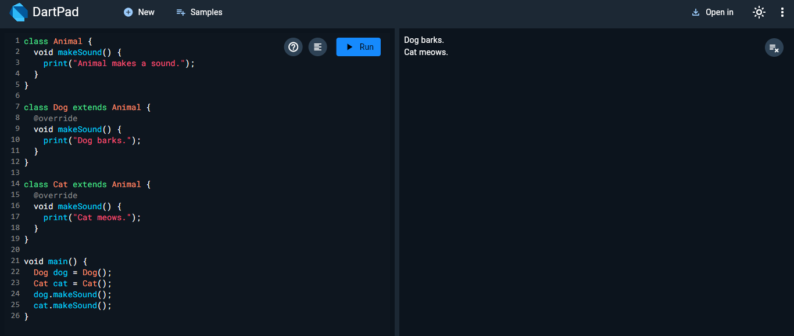

2)

class Car {

String brand;

String model;

int year;

Car(this.brand, this.model, this.year);

Car.oldCar(this.brand, this.model) : year = 2000;

void printDetails() {

print("Brand: $brand, Model: $model, Year: $year");

}

}

void main() {

Car car1 = Car("Toyota", "Corolla", 2021);

Car car2 = Car.oldCar("Ford", "Mustang");

car1.printDetails();

car2.printDetails();

}

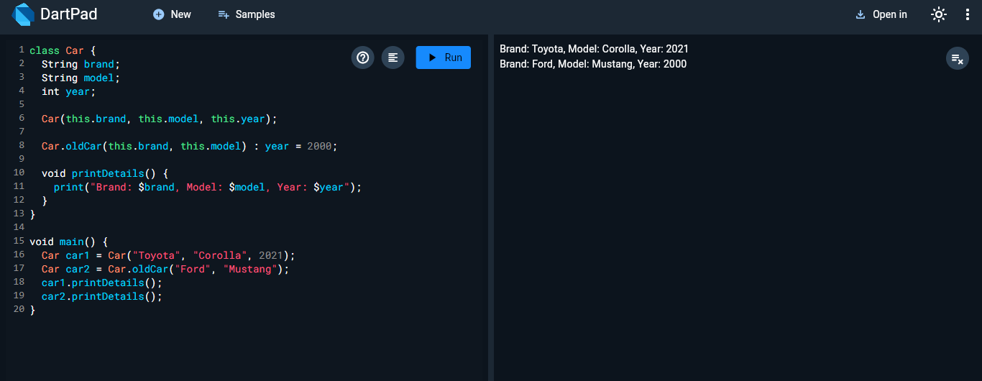

3)

class Student {

String name;

double grade;

Student(this.name, this.grade);

void showInfo() {

print("$name has a grade of $grade");

}

}

void main() {

List<Student> students = [

Student("Alice", 95.5),

Student("Bob", 88.0),

Student("Charlie", 91.0)

];

for (var student in students) {

student.showInfo();

}

}

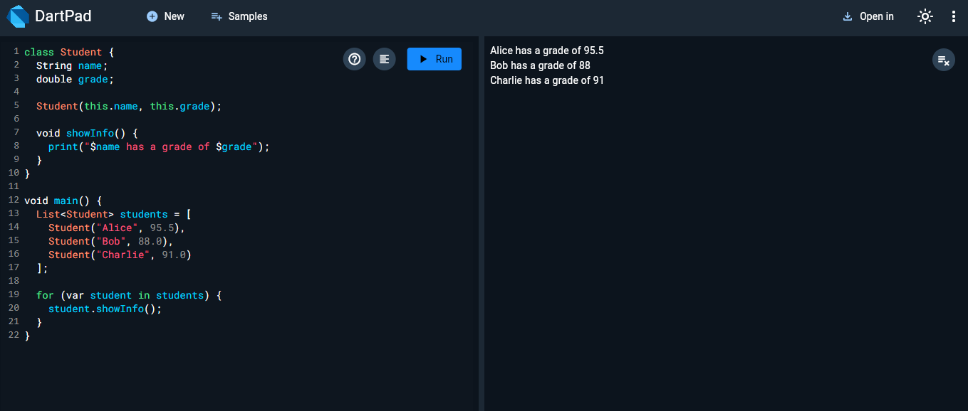

4)

class Book {

String title;

String author;

int pages;

Book(this.title, this.author, this.pages);

void bookInfo() {

print("Title: $title, Author: $author, Pages: $pages");

}

}

void main() {

Book book1 = Book("1984", "George Orwell", 328);

Book book2 = Book("To Kill a Mockingbird", "Harper Lee", 281);

Book book3 = Book("The Great Gatsby", "F. Scott Fitzgerald", 180);

book1.bookInfo();

book2.bookInfo();

book3.bookInfo();

}

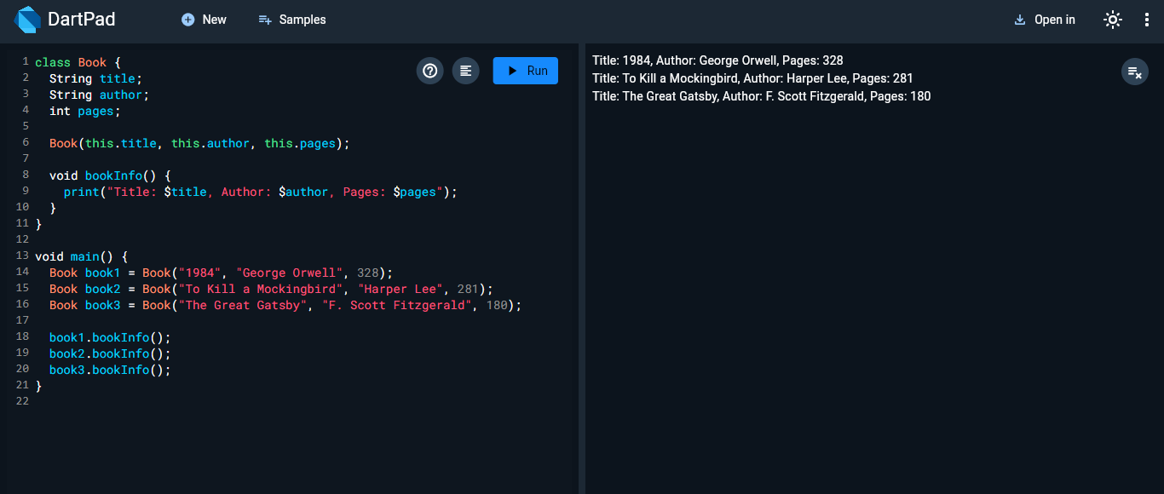

5)

class Temperature {

double _celsius;

Temperature(this._celsius);

double toFahrenheit() {

return _celsius * 9 / 5 + 32;

}

double toKelvin() {

return _celsius + 273.15;

}

}

void main() {

Temperature temp = Temperature(25);

print("Fahrenheit: ${temp.toFahrenheit()}");

print("Kelvin: ${temp.toKelvin()}");

}

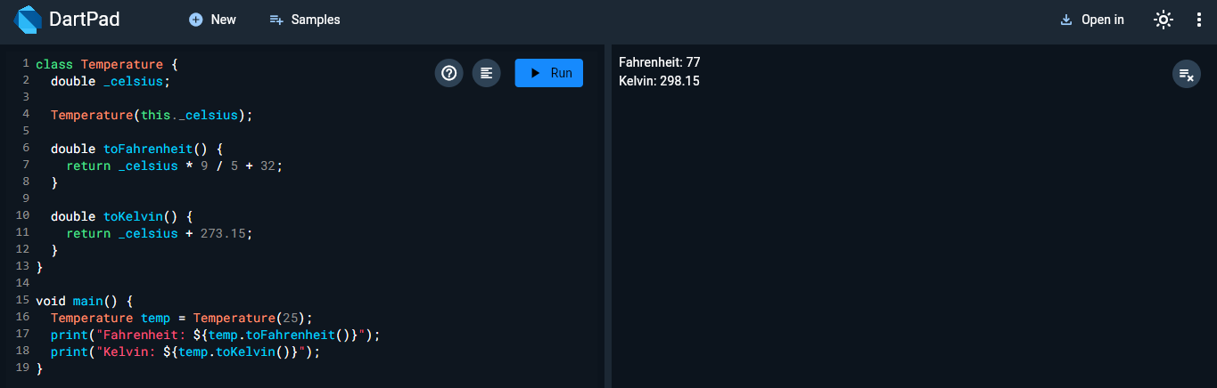

6)

class Rectangle {

double _width;

double _height;

Rectangle(this._width, this._height);

double get width => _width;

double get height => _height;

double get area => _width * _height;

double get perimeter => 2 * (_width + _height);

set width(double value) {

if (value > 0) _width = value;

}

set height(double value) {

if (value > 0) _height = value;

}

}

void main() {

Rectangle rect = Rectangle(5, 10);

print("Area: ${rect.area}");

print("Perimeter: ${rect.perimeter}");

}

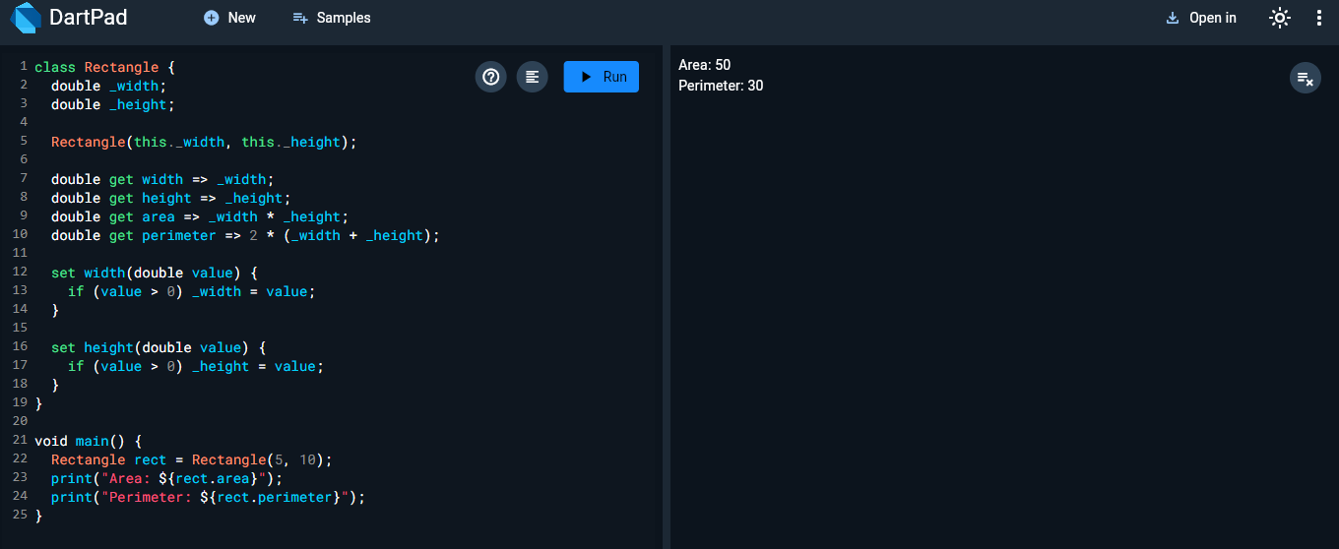

7)

class Calculator {

double add(double a, double b) {

return a + b;

}

double subtract(double a, double b) {

return a - b;

}

double multiply(double a, double b) {

return a * b;

}

double divide(double a, double b) {

return a / b;

}

}

void main() {

Calculator calc = Calculator();

print("Add: ${calc.add(5, 3)}");

print("Subtract: ${calc.subtract(5, 3)}");

print("Multiply: ${calc.multiply(5, 3)}");

print("Divide: ${calc.divide(5, 3)}");

}

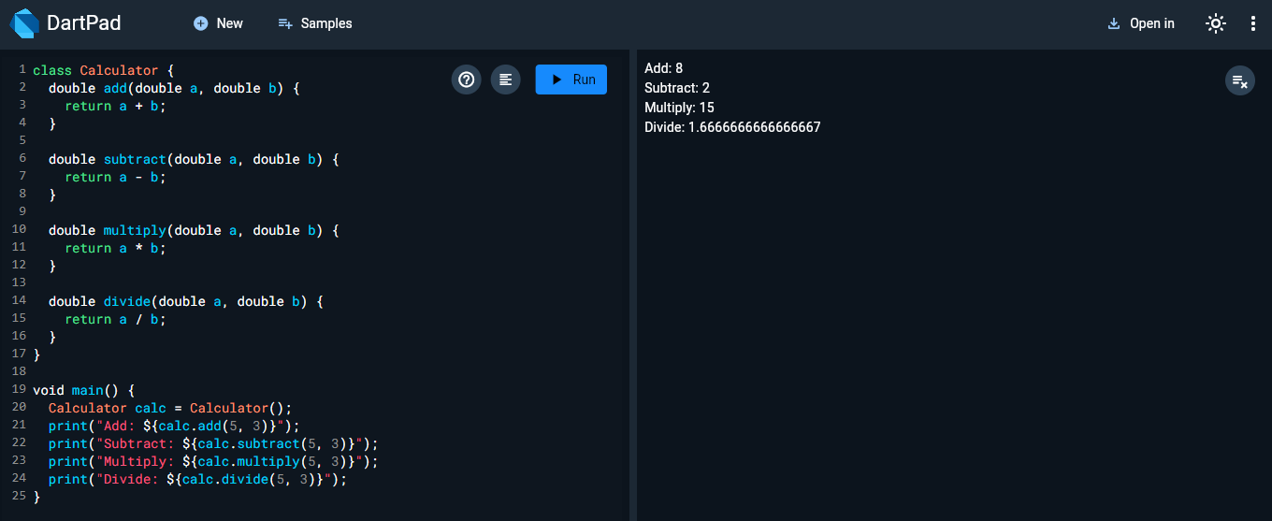

8)

class Movie {

String title;

String director;

String rating;

Movie(this.title, this.director, [this.rating = "Not Rated"]);

void showDetails() {

print("Title: $title, Director: $director, Rating: $rating");

}

}

void main() {

Movie movie1 = Movie("Inception", "Christopher Nolan", "PG-13");

Movie movie2 = Movie("The Matrix", "Lana Wachowski");

movie1.showDetails();

movie2.showDetails();

}

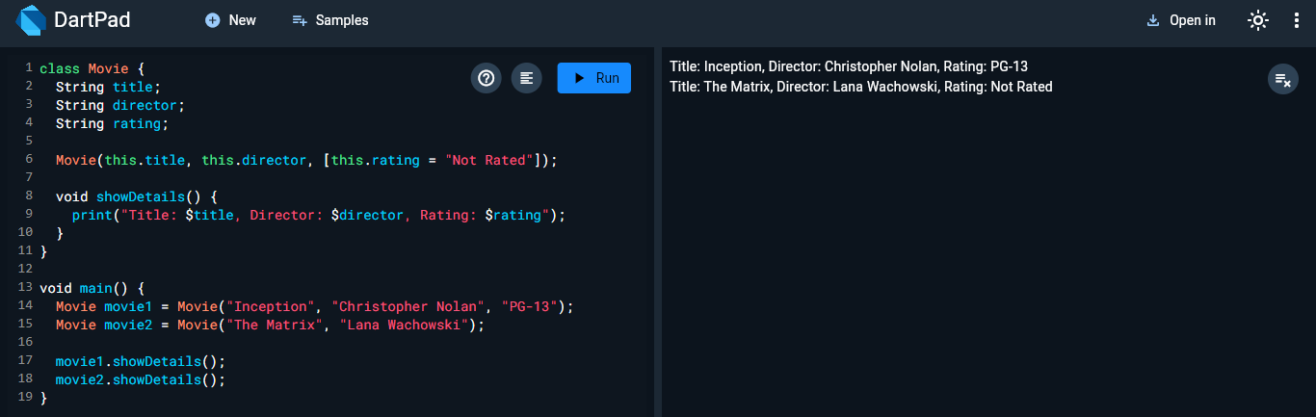

9)

class SmartDevice {

String brand;

String model;

SmartDevice(this.brand, this.model);

void showDetails() {

print("Brand: $brand, Model: $model");

}

}

class Smartphone extends SmartDevice {

String os;

Smartphone(String brand, String model, this.os) : super(brand, model);

@override

void showDetails() {

print("Brand: $brand, Model: $model, OS: $os");

}

}

class Laptop extends SmartDevice {

String ram;

Laptop(String brand, String model, this.ram) : super(brand, model);

@override

void showDetails() {

print("Brand: $brand, Model: $model, RAM: $ram");

}

}

void main() {

Smartphone phone = Smartphone("Apple", "iPhone 12", "iOS");

Laptop laptop = Laptop("Dell", "XPS 13", "16GB");

phone.showDetails();

laptop.showDetails();

}

